Objectives:

* Classes, static methods vs. instance methods
* Objects, copy objects

**There are 3 challenge exercises, each worth 33.3%**

An **object** has three characteristics: example of objects is >> bag, pencil, board, book, dog, cat, person, Colleges etc.…

* **State**: represents the data (value) of an object.
  + **Example**: object could be a bag and the state would be the color of the bag
* **Behavior**: represents the behavior (functionality) of an object such as deposit, withdraw, something that takes an action

Create a class and name it **c1**, then type in the following code below:

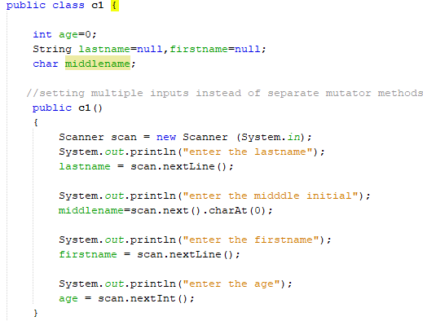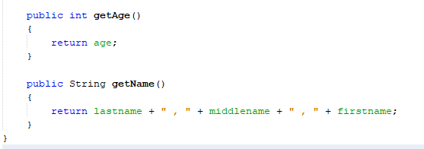

Create a class and name it **c2**, then type in the following code below:

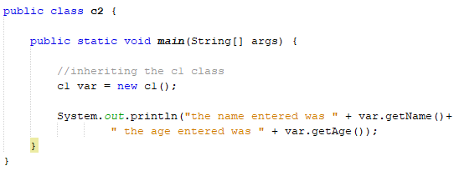

**Challenge Class Exercise #1**

For the **c1** class, ask the user to enter the following objects >> address, city, state and zip code and from the **c2** class return the fields

**#1 print screen the output with the code below here**

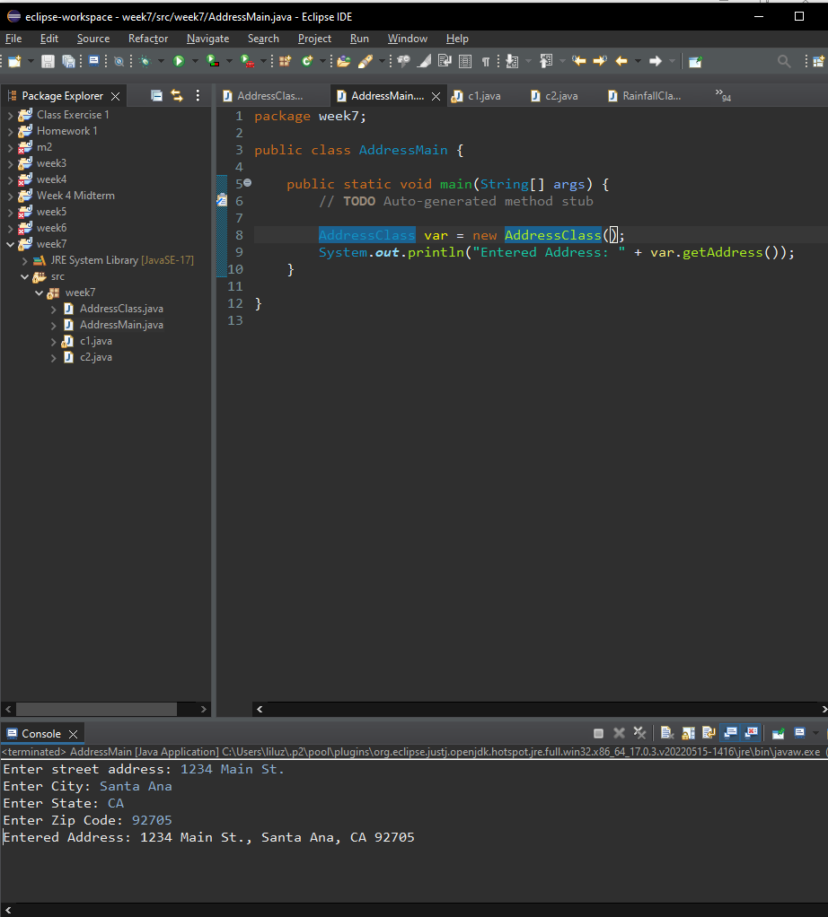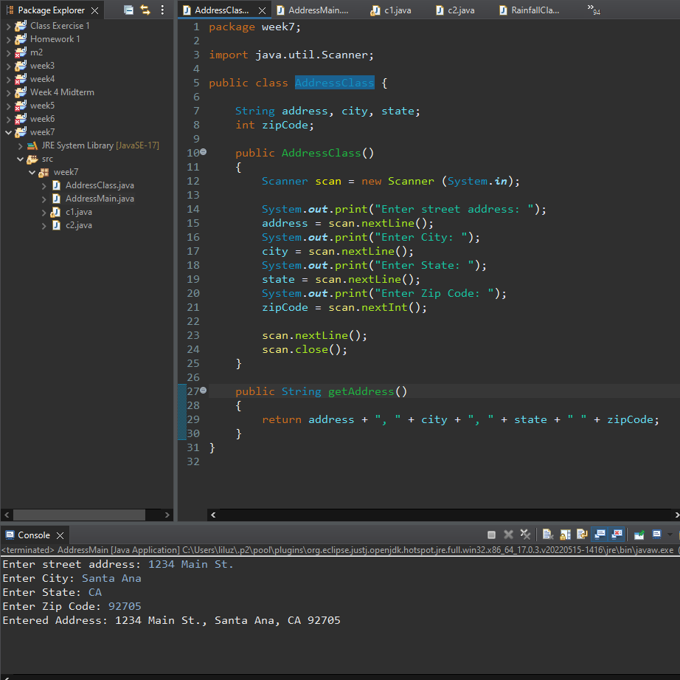

**STATIC** **METHODS**: are the methods in Java that can be called without creating an object of class. They are referenced by the **class name itself** or reference to the Object of that class.

**When to use static methods?003F**

* When you have code that can be shared across all instances of the same class, put that portion of code into static method.

Create a class and name it **c3**, then type in the following code:

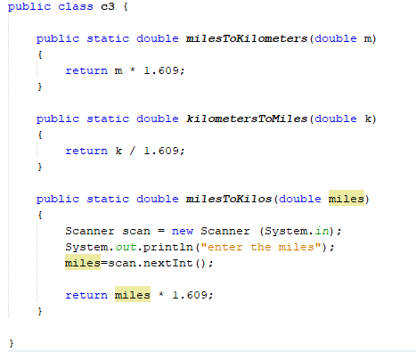

Create a class and name it **c4**, then type in the following code:

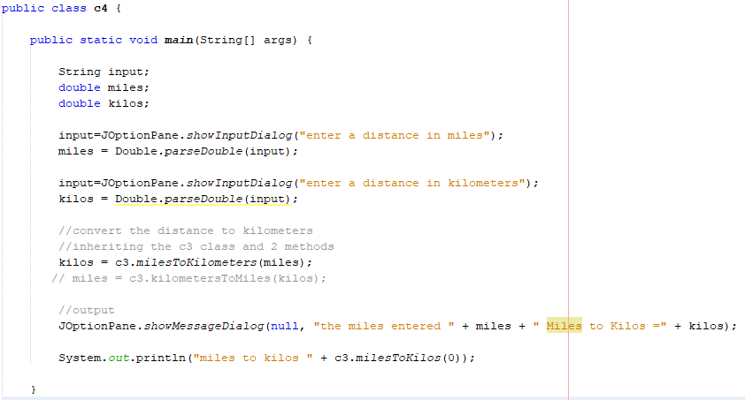

**Challenge Class Exercise #2**

For the **c3** class use a scanner class that will allow the user to input 2 numbers then ADD, SUBTRACT, MULTIPLY and then DIVIDE the numbers, then from the **c4** class return the values

**#2 print screen the output with the code below here**

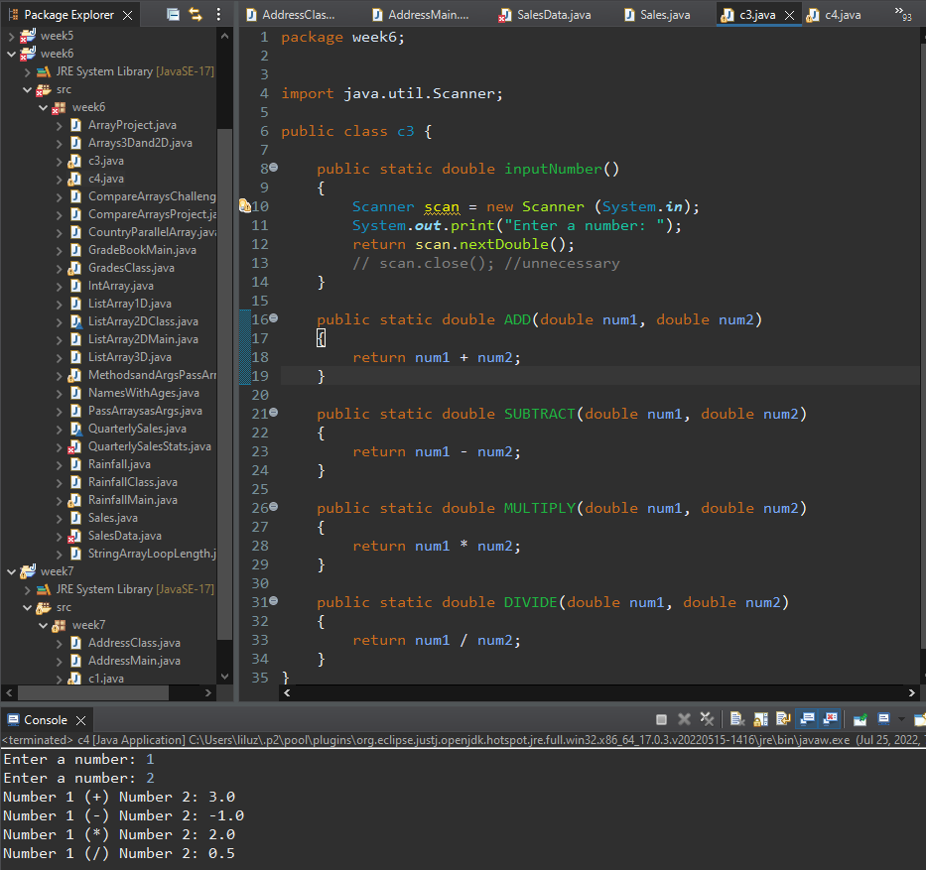

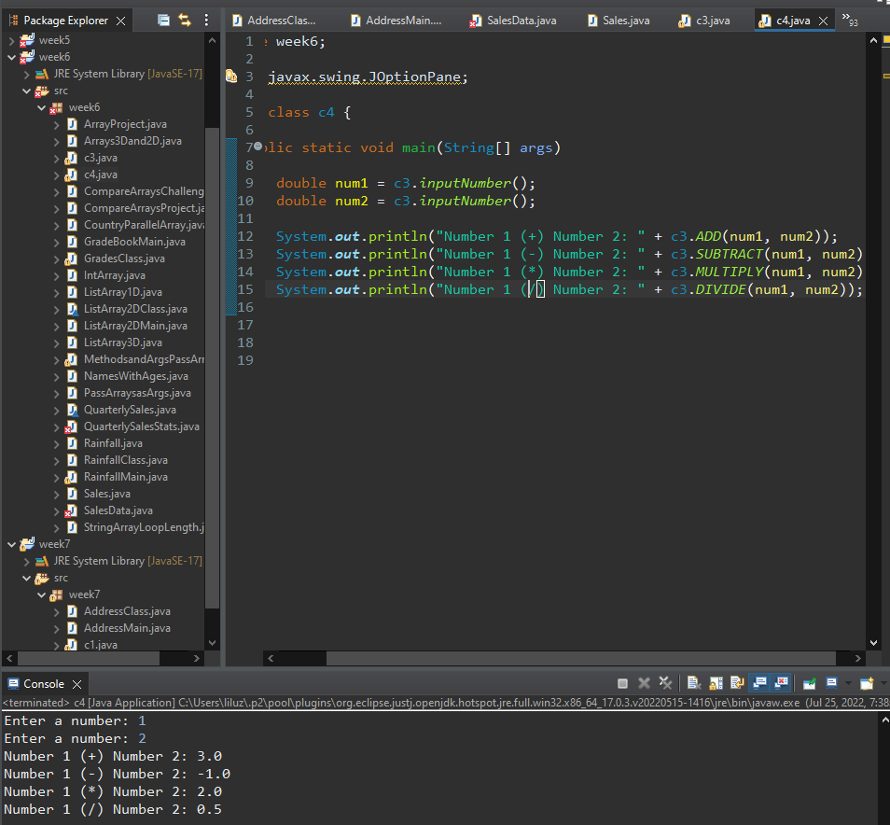

Create a class and name it **c5**, type in the following code:

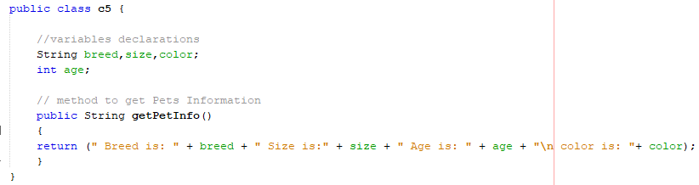

Create a class and name it **c6**, type in the following code:

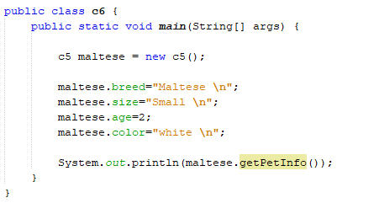

**Challenge Class Exercise #3**

Create a second method for the **c5** class and include the scanner class to ask the user to input the breed, size, age and color of a type of dog and then return it from the main class for the **c6** class

**#3 print screen your output with the code below here**

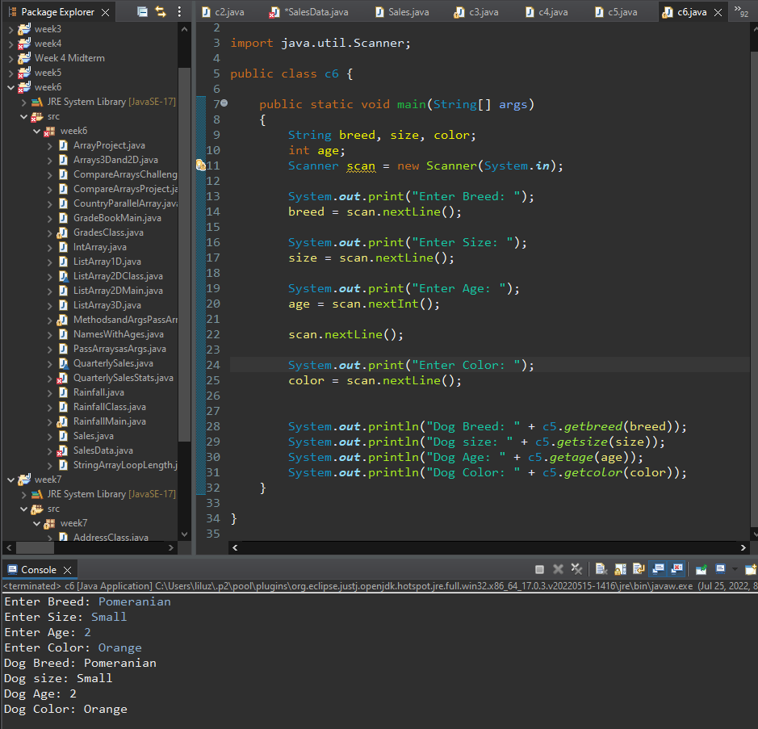

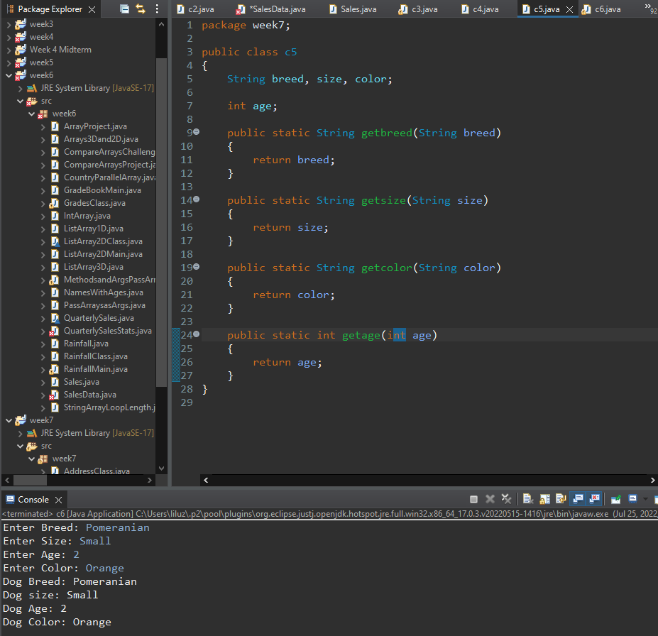

**Instance** **method:** are methods which require an object (*id*, *name*, *salary*) of its class to be created before it can be called. To invoke an instance method, we must create an Object of the class in within which it defined.

Create a class and name it **c7,** and type in the following code:

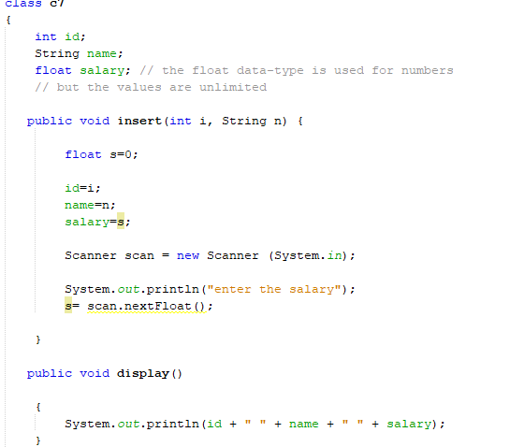

Create a class and name it **c8**, and type in the following code  
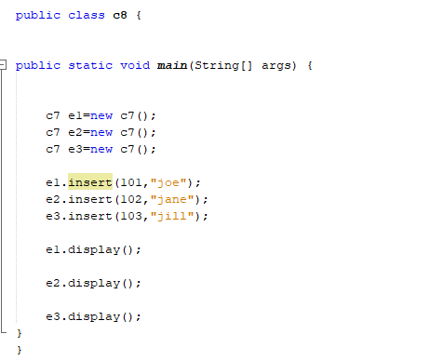

**Passing Objects as Arguments**

Create a class and name the class **Rectangle,** and type in the following code: See next page…

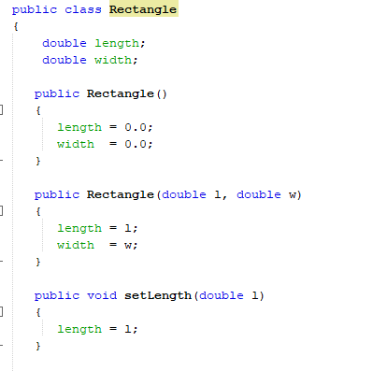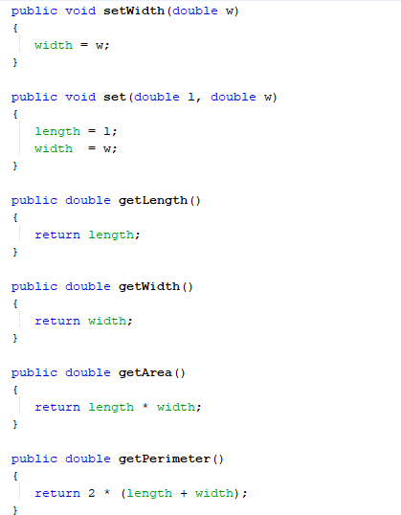

Create a class and name the class **RectangleGet,** and type in the following code:

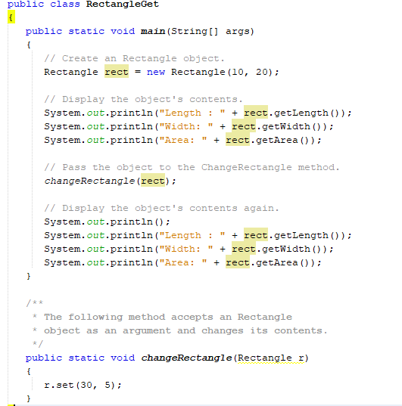

**This example is based on the UML Diagram page 506 (Figure 8-8) Stock Class**

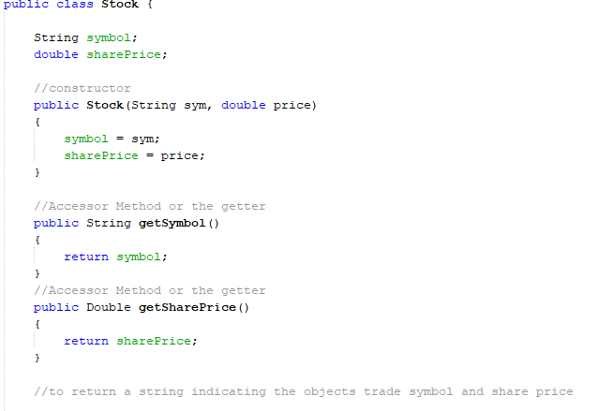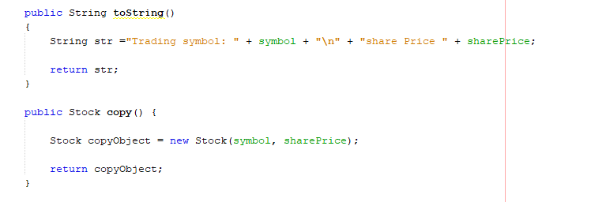

**The main class**

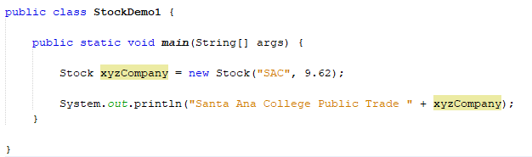

**Submit this document to Module 7 Class Exercise #7**